Resistive transducers are very important devices from an industrial point of view. They are used in calculating physical quantities like temperature and pressure which you would otherwise find really difficult to measure. Transducers can make industrial processes a lot simpler. A resistive transducer is basically a type of transducer whose resistance changes according to the change in environmental conditions. We are able to measure this change in resistance using various kinds of measuring devices. One of the most important advantages of the resistive transducer is that the measurement of the change in resistance can be done using both current and voltage. The output is also quite fast.

What is a Resistive Transducer?
A resistive transducer is an electronic device that is capable of measuring various physical quantities like temperature, pressure, vibration, force, etc. These physical quantities are otherwise extremely difficult to measure as they can change easily. However, using this transducer, you can easily calculate the values of these quantities. The resistance of this transducer changes concerning the change in the physical quantities.
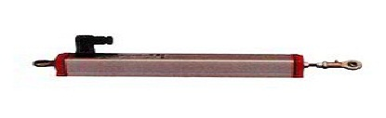
resistive-transducer
These transducers can function in both primary as well as in secondary mode but most of the time it is used as secondary. This is because the output of the primary transducer can be given as an input to this transducer. The primary transducers are used in the conversion of physical quantities to mechanical signals while the secondary transducers are used to convert the physical quantities to electrical signals directly without first converting them to mechanical signals. The resistive transducers are of different types like resistive pressure transducers, thermistors resistors, LDR, etc.

Working of a Resistive Transducer
A resistive transducer is mainly used in the calculation of temperature, displacement, pressure, force. The working of a resistive transducer can be explained by considering a conductor rod as the transducer. The transducer works on the principle of the length of the conductor.
The length of the conductor is directly proportional to its resistance and is inversely proportional to its cross-sectional area. Here, if we consider the length of the conductor as L, the cross-sectional area as A, the resistance as R and the resistivity as ρ, then the resistance can be denoted as
R = ρL/A
The resistance of the transducers can vary because of the change in environmental conditions as well as the physical properties of the conductor. Measuring devices like AC or DC can be used to measure the change in resistance.

Resistive Transducer Circuit
The resistive transducer consists of a long conductor whose length can be varied with time. One end of the conductor is connected while the other end is connected to a brush or a slider that can freely move along the length of the transducers.
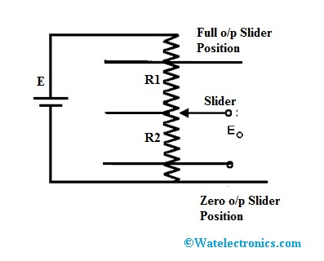
resistive-transducer-circuit-diagram
We can calculate the distance of the object by connecting the object to the slider of the resistive transducer. Whenever we apply energy to the object to displace it from its initial position, the slider will move along the length of the conductor as a result of which the length will change. The change in the length of the conductor will cause the resistance of the conductor to change as well. A transducer works in a way similar to that of a potentiometer which is used in the calculation of the angular and linear displacement

Advantages
The main advantages of the resistive transducer are as follows:
- The resistive transducer can be used to give very quick results.
- The resistive transducers are available in various sizes and they have a considerably high amount of resistance.
- We can use both AC or DC for calculating the change in resistance.
- They are quite affordable and can be easily available in the market.
- W can use this transducer in various applications even when they are not a necessity.
- It can be used to give accurate results.

Disadvantages
Some of the major disadvantages of resistive transducers are:
- A lot of power is wasted in moving the sliding contacts.
- The sliding contacts can produce a lot of noise.

Applications of a Resistive Transducer
- A resistive transducer is mainly used to measure the temperature in various kinds of applications. When there is a change in temperature, the temperature coefficient of the resistive transducer changes which can be used to determine the change in temperature.
- The resistive transducer can function as a potentiometer where the resistance of the transducer can be varied by changing the length of the conductor.
- A resistive transducer can be used in the calculation of the displacement. When we apply strain on the resistor, the resistance changes. This characteristic can be used in the measurement of displacement, force, and pressure.

